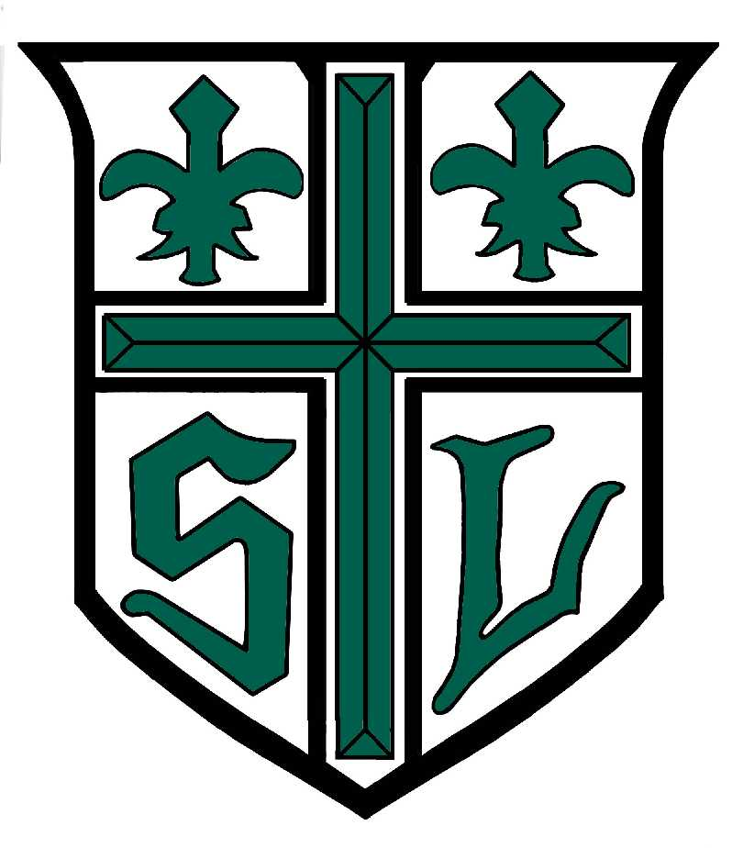ST. LEO SCHOOL
Office of Development
120 Main Street
Leominster, MA 01453
(978) 537-0142
stleodevelopment@hotmail.com

Summer 2017

Dear Friend of St. Leo School,

The time is upon me once again to announce our Annual St. Leo School Golf Classic, which will tee off this fall. The yearly tournament helps to defray education costs at St. Leo School. Our golf tournament is scheduled for Monday, October 2, 2017 at the prestigious Oak Hill Country Club in Fitchburg, Ma.

St. Leo School is a Catholic Elementary school that provides its students with exceptional curriculum in an atmosphere that lends itself to a strong sense of community, caring for one another, and discipline. These ideals are desirable and attained by our diverse population. St. Leo School prides itself on being non-discriminatory and has a 90% college acceptance rate of our alumni. Throughout the years many St. Leo School alumni have helped to enrich our surrounding communities through service, volunteerism and work.

Knowing your understanding of how important successful education is to our children, our leaders of tomorrow, please show your sincere commitment to our mission by becoming a sponsor of this fund-raising event. The funds received will go directly to the school. Please become a sponsor of this year’s Golf Classic.

A “Platinum Sponsorship” level will be awarded for donations of $1,500.00 or more. The platinum sponsors’ names will appear on our main Platinum Sponsor Banner during the event. The donor’s names will be prominently displayed during our luncheon and dinner. Sponsorships will appear in our programs.

For a donation of $500.00, a “Gold Sponsorship” this level of sponsorship will secure the placement of signage closest to our registration and dining areas. Sponsorships will appear in our programs.

For a $300.00 donation a “Silver Sponsorship” level will be awarded. Each silver sponsorship will be considered a competition sponsor and will receive prominent advertisement for example, on the “Straightest/Longest Drive” or “Closest to the Pin” holes and be listed in our program.

Lastly, a “Tee Sponsorship” level for $250.00 would have your company’s name displayed at one of the 18 golf tees and in our program.

I hope you will consider becoming a sponsor for the St. Leo School Golf Classic, a fine way to support the future of St. Leo School and educational excellence. I am enclosing a registration /sponsorship form for your convenience. Your sponsorship donation is greatly appreciated.

Sincerely,

_________________________________
Reverend William E. Champlin, Pastor

Enc.

